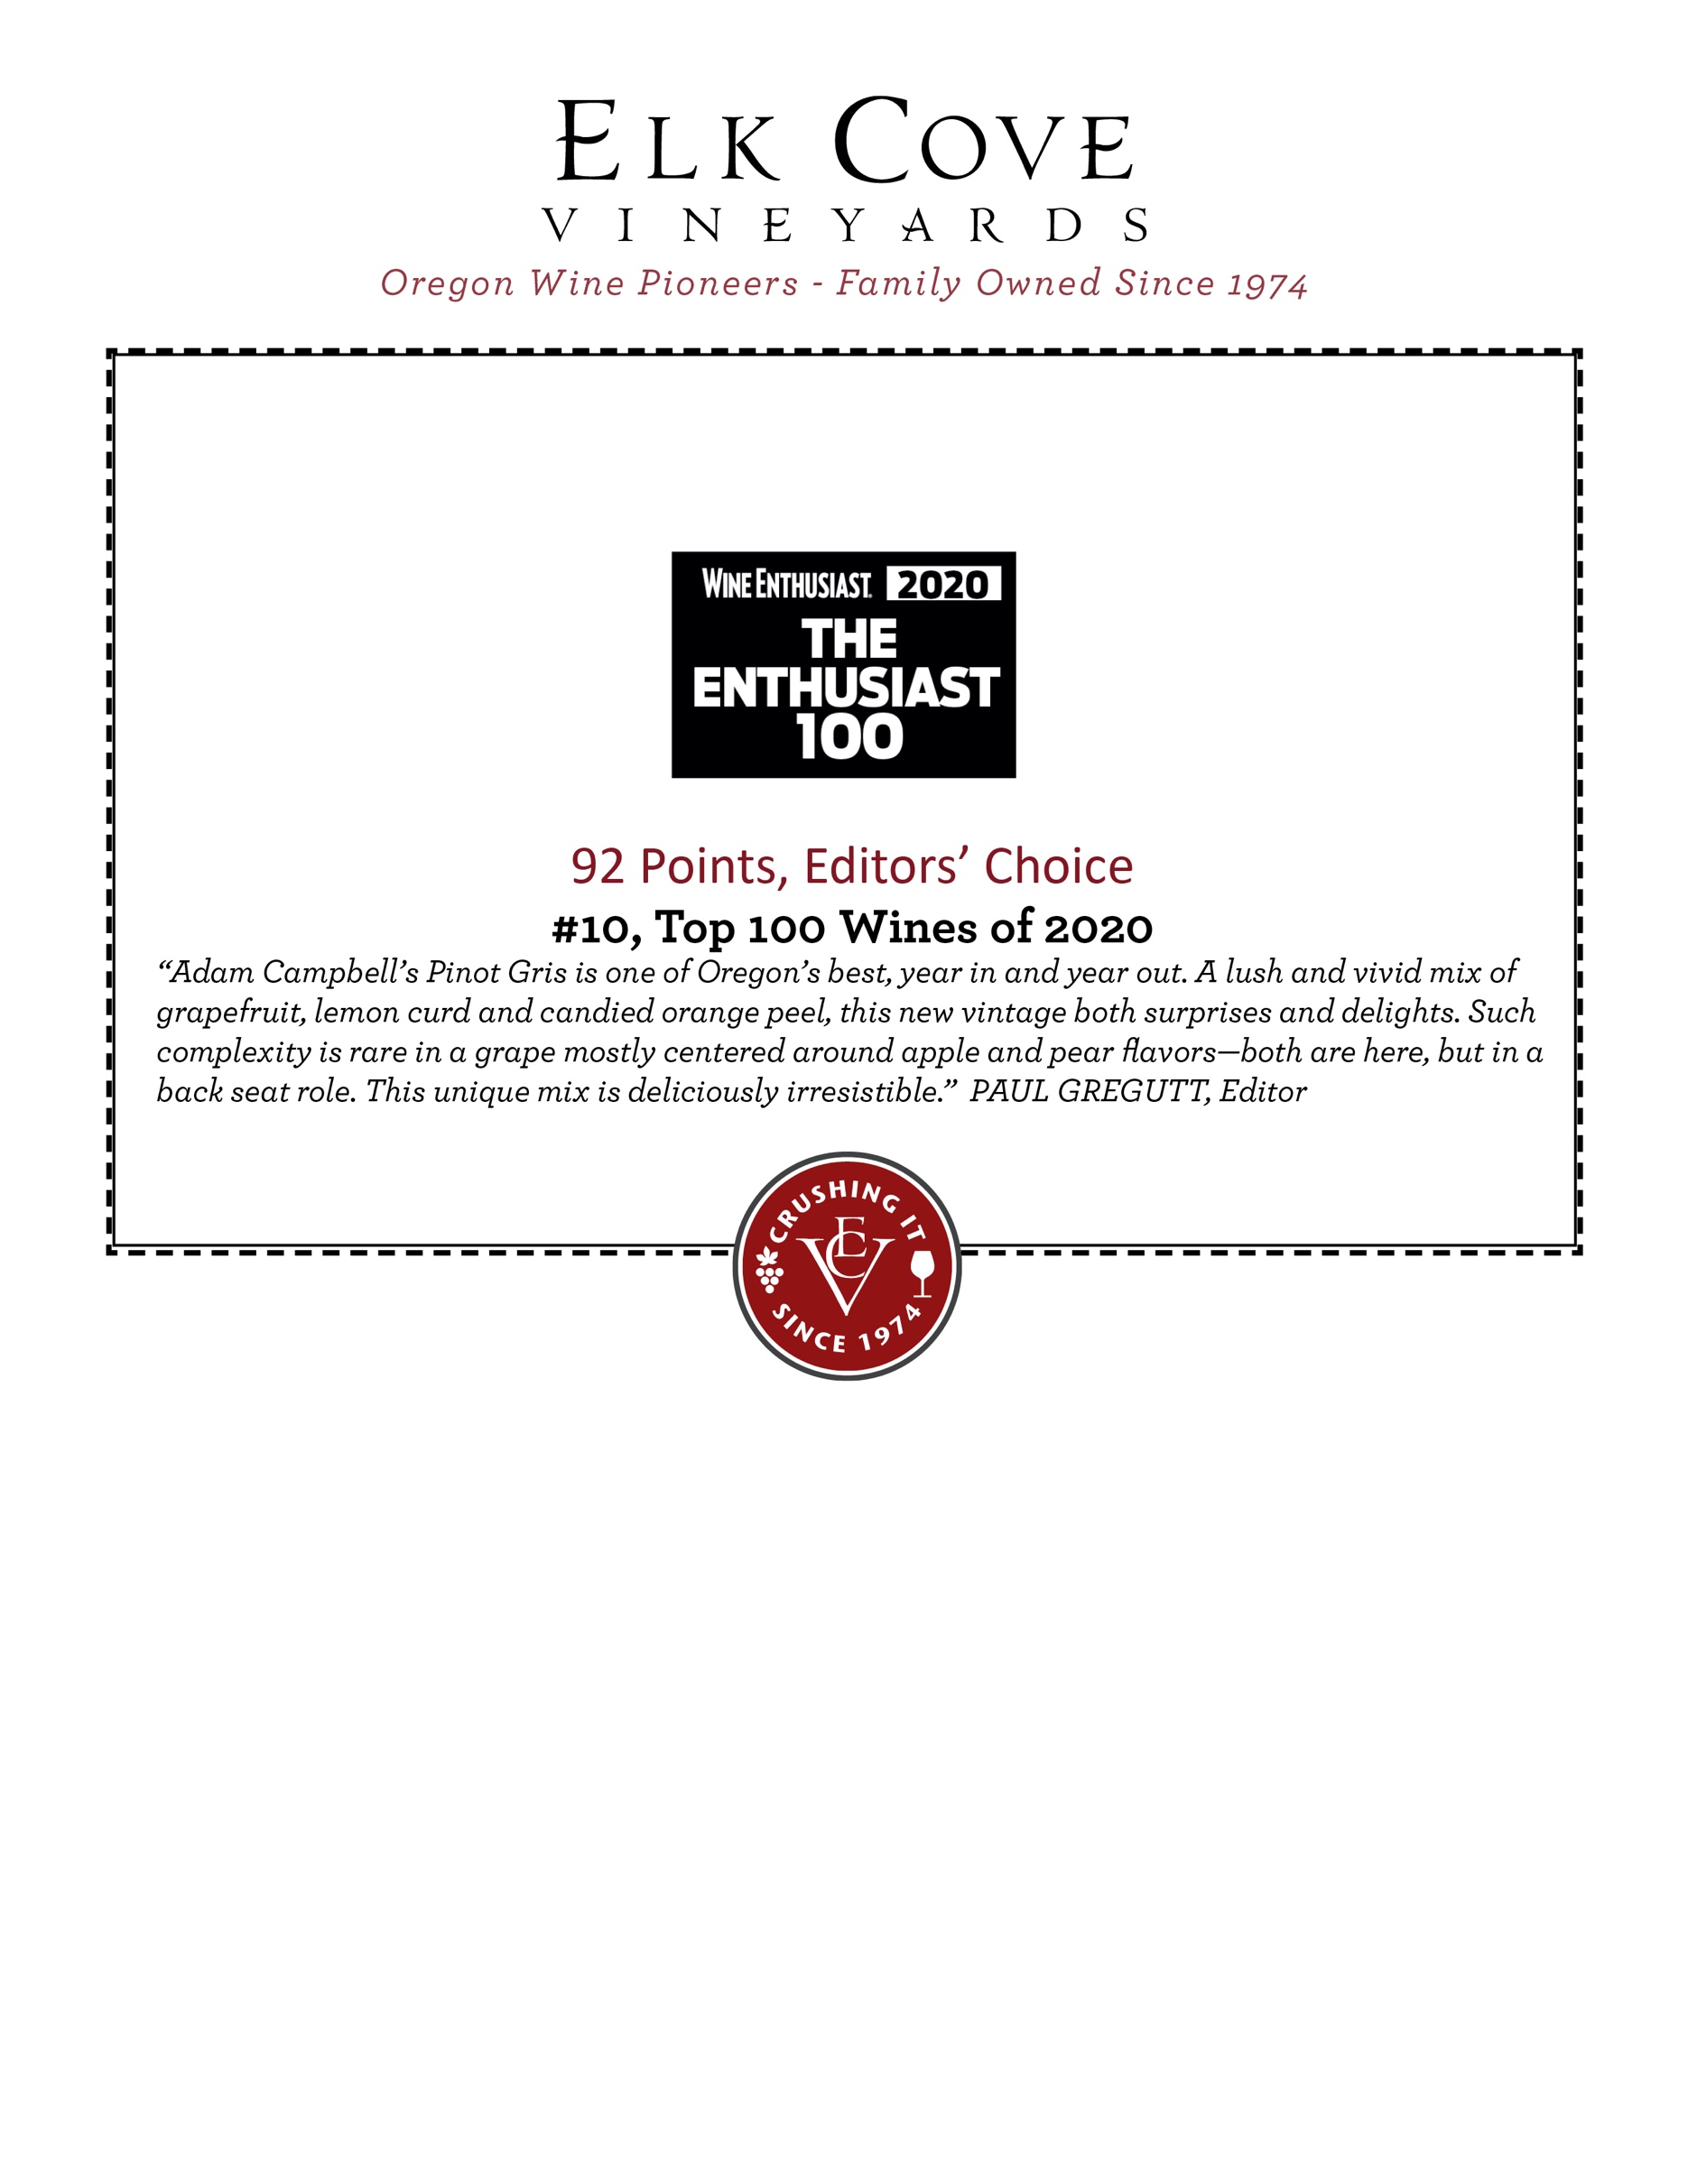

PINOT GRIS WILLAMETTE VALLEY $XX.XX

MORE CORE WINES:

PINOT NOIR WILLAMETTE VALLEY $XX.XX

PINOT BLANC WILLAMETTE VALLEY $XX.XX

RIESLING WILLAMETTE VALLEY $XX.XX

