Elk Cove Distributor Retreat
2019 Camper Contact List

 | Camper | State | Distributor | Cell Phone | Email
1 |  | CO | RNDC
2 |  | OK | RNDC
3 | Aaron Rogers | MS | Southern Glazers Wine & Spirits | (601)-498-0052 | Aaron.Rogers@sgws.com
4 | Alison Zemann | NJ | Wilson Daniels | (732)-841-2382 | AlisonZemann@wilsondaniels.com
5 | Angela Thompson | WA | Winebow | (646)-283-6683 | angela.thompson@winebow.com
6 | Bobby Labartino | GA | Empire Distributing
7 | Caitryn Matthews | OR | Galaxy Wine Company | (541)-601-6357 | caitrynmathews@galaxywdw.com
8 | Carl Vitale | CT | Wilson Daniels | (203)-430-5815 | CarlVitale@wilsondaniels.com
9 | David Hunter | NM | Fiasco Fine Wines | (505)-259-8318 | david@fiascowine.com
10 | Eric Dutton | CO | RNDC |  | Eric.Dutton@RNDC-USA.COM
11 | Eric Steckler | IL | Winebow | (217)-778-9882 | Eric.steckler@winebow.com
12 | Galen Crippin | TX | Victory Wine Group
13 | James Myers | NY | Wilson Daniels | (585)-489-7456 | JamesMyers@wilsondaniels.com
14 | Jerianna Shultz | MT | George’s Distributing | (406)-250-9271 | jeriannas@georgesdistributing.com
15 | Jessica Mares | NE | Quail Distributing | (308)-325-9261 | jmares@quaildist.com
16 | John Davids | IL | Winebow | (312)-593-5543 | John.davids@winebow.com
17 | Keith Kane | MA | Martignetti/Carolina Wine Co. | (203)-745-9949 | kkane@martignetti.com
18 | Kevin Nadolski | MI | Vintage Wine Company | (617)-909-6604 | knadolski@vwcmi.com
19 | Kyle Troth | AZ | Quench Fine Wines | (480) 510-7616 | kyle.troth@quenchaz.com
20 | Matt Day | CA | Mosaic Wine Alliance | (949) 351-0960 | matt@mosaicwinealliance.com
21 | Paige Dean | WA | Winebow | (206)769-5529 | Paige.Dean@winebow.com
22 | Phil Van Ziepel | ID | S&C Wines | (208)-720-2910 | pvanzeipel@sandcwines.com
23 | Randy Hagerman | OR | Galaxy Wine Company | (551)-486-6626 | Randy@galaxywinecompany.com
24 | Saree Mims | TX | Victory Wine Group
25 | Stacy Laverell | MI | Vintage Wine Company | (616)-433-5505 | slaverell@vwcmi.com
26 | Sue Nordberg | MA | Martignetti/Carolina Wine Co. | (978)-790-3213 | snordberg@martignetti.com
27 | Tavia Babb | OR | Galaxy Wine Company | (503)-799-7959 | taviababb@galaxywdw.com
28 | Tim Sayles | IN | Crossroad Vintners | (219)- 488-4562 | tim@crossroadvintners.com
29 | Vishaka Johnson | AZ | Quench Fine Wines | (602) 820-4447 | Vishaka.johnson@quenchaz.com
30 | Wes Kollar | CA | Mosaic Wine Alliance | (714) 240-2318 | wes@mosaicwinealliance.com

Elk Cove Distributor Retreat Staff Contact List

Name | Position | Email | Phone
Adam Campbell | Owner & Winemaker | adam@elkcove.com
Heather Perkin | Associate Winemaker | heather@elkcove.com
Travis Watson | Vineyard Manager | travis@elkcove.com
Shirley Brooks | VP of Sales & Marketing | shirley@elkcove.com | 503-706-0683
Katherine Stalmann | Direct Sales Manager | katherine@elkcove.com
Todd Stewart | Director of National Sales | todd@elkcove.com | 704-516-3692
Claire Thomas | Corporate Sales Manager | claire@elkcove.com | 843-260-5797
Cam Christie | National Sales Manager | cam@elkcove.com | 415-676-0338
Dani Boxford-Heidle | National Sales Manager | dani@elkcove.com | 214-830-5601
Taylor Theis | Wine Club Manager | taylor@elkcove.com
Anna Campbell | Creative Director | anna@elkcove.com
Robert Verant | Chief Financial Officer | rob@elkcove.com
Kaitlin Mueller | Sales Coordinator | kaitlin@elkcove.com

2019 Elk Cove Distributor Retreat
Gilbert Hall Room Assignments

Room | Name | State |  | Room | Name | State
G301A | Vishaka Johnson | AZ |  | G407A | Galen Crippin | TX
G301B | Jessica Mares | NE |  | G407B | Bobby Labartino | GA
G301C | Paige Dean | WA |  | G407C | James Myers | NY
G301D | Dani B. Heidle | ECV |  | G407D | Cam Christie | ECV
G401A | Kyle Troth | AZ |  | G408A | Eric Steckler | IL
G401B | Wes Kollar | CA |  | G408B | David Hunter | NM
G401C | Eric Dutton | CO |  | G408C | Randy Hagerman | OR
G401D | Keith Kane | MA |  | G408D
G402A | Caitryn Matthews | OR |  | G409A | John Davids | IL
G402B | Angela Thompson | WA |  | G409B |  | OK
G402C | Saree Mims | TX |  | G409C |  | CO
G402D | Alison Zemann | NJ |  | G409D
Room | Name | State
G403A | Matt Day | CA
G403B | Carl Vitale | CT
G403C | Aaron Rogers | MS
G403D | Todd Stewart | ECV
G404A | Stacy Laverell | MI
G404B | Jerianna Shultz | MT
G404C | Tavia Babb | OR
G404D | Sue Nordberg | MA
G405A | Phil Van Ziepel | ID
G405B | Tim Sayles | IN
G405C | Kevin Nadolski | MI
G405D

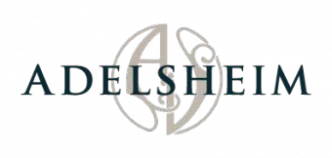

16800 NE Calkins Lane, Newberg, Oregon 97132 503-538-3652
Adelsheim.com

………………………………………………………………………………………………………………………………………………………………….

OWNERS Jack & Lynn Loacker

WINEMAKER Gina Hennen
VINEYARD MANAGER Kelli Gregory FIRST VINTAGE 1978

VINEYARD ACRES FARMED 185
VARIETIES PRODUCED Pinot noir, Pinot gris, Chardonnay, Pinot blanc, Syrah

CASE PRODUCTION 42,500

SUSTAINABIITY CERTIFICATIONS LIVE, Salmon Safe

………………………………………………………………………………………………………………………………………………………………….

Adelsheim Vineyard was founded in 1971 and is still family- and Oregon-owned. We create remarkable Pinot noir and Chardonnay wines with most of the grapes now coming from our ten estate vineyards in the Chehalem Mountains. The variations in the vineyard soils, elevations and mesoclimates give us important differences in ripening times and in the flavors, tannins, sugars and acidities of the grapes. Our wines always taste of their place. In the winery we are guided by traditional techniques and non-intervention, but we are also not afraid of experimentation to achieve our high goals. We were part of the founding of Oregon’s wine industry and are still industry leaders, aiming to bring Oregon wines to the world while championing the traditions of collaboration and a focus on quality that have always been the hallmarks of the Willamette Valley wine community. Visit adelsheim.com for more information.
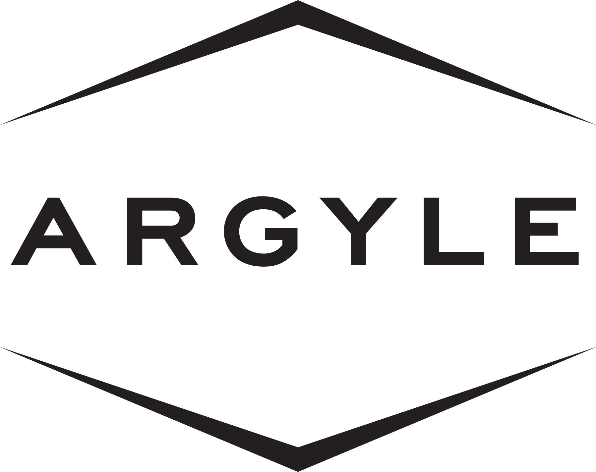

691 Highway 99W, Dundee, OR 97115
503-538-8520
argylewinery.com
………………………………………………………………………………………………………………………………………………………………….

OWNER Lion Pty Ltd.

WINEMAKER Nate Klostermann

VINEYARD MANAGER Geoff Hall

YEAR ESTABLISHED 1987

VINEYARD ACRES FARMED Approximately 400

VARIETIES PRODUCED Sparkling, Chardonnay, Riesling, Pinot noir

CASE PRODUCTION 80,000

SUSTAINABILITY CERTIFICATIONS LIVE

………………………………………………………………………………………………………………………………………………………………….

Argyle has been farming vineyards and making fine wine in the Willamette Valley since 1987. What began as a conviction to grow world class sparkling wine expanded to an ambition to build a legacy with long-aging wines, be it Sparkling wine, Riesling, Chardonnay or Pinot noir. Argyle has deep roots in the community, and a commitment to the long-term health of the land and the Oregon wine industry.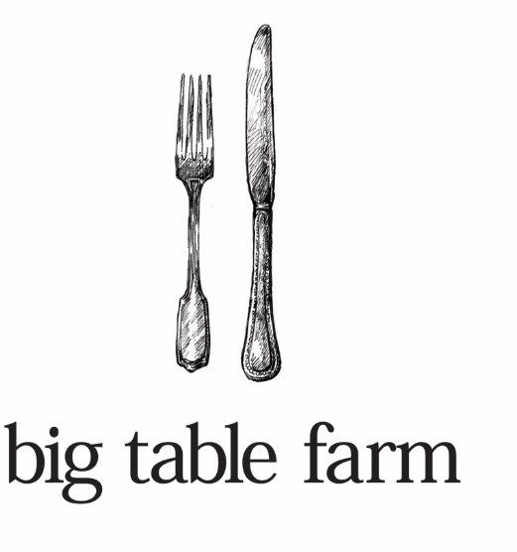

26851 NW Williams Canyon Road, Gaston, Oregon 97119 503.662.3129
Bigtablefarm.com

…………………………………………………………………………………………………………………………………………………….

OWNERS Brian Marcy and Clare Carver

WINEMAKER Brian Marcy

FIRST VINTAGE 2006

VARIETIES PRODUCED Pinot noir, Chardonnay, Syrah

CASE PRODUCTION 4,000

SUSTAINABILITY CERTIFICATIONS Some vineyards are Organic, some Bio-dynamic, some LIVE

…………………………………………………………………………………………………………………………………………………….

In 2006 we moved to Oregon from Napa, where Brian had been working in wine for ten years. We bought property in the Willamette Valley (about an hour outside of Portland). We started with a dream and made our first 150 cases in 2006. This Oregon adventure is inspired by our desire to grow grapes, make wine, and to have the space for all of Clare’s animals and Brian’s projects. We named our farm and winery after our goal to provide a gracious and welcoming table for ourselves and friends, with a cornucopia of hand-crafted food and wine. And now, just over ten years after we took the leap, we have developed this land into a working farm and built a barn and winery. We feel lucky to live here and we are still in awe and deeply grateful for the chance to build this dream and share it with you!



6905 Spring Valley Rd NW, Salem, OR 97304 503-375-3068
cristomvineyards.com

…………………………………………………………………………………………………………………………………………………….

OWNER Tom Gerrie

WINEMAKERS Steve Doerner, Tom Gerrie

VINEYARD MANAGER Tom Gerrie

FIRST VINTAGE 1992

VINEYARD ACRES FARMED 93+

VARIETIES PRODUCED Pinot noir, Chardonnay, Syrah, Viognier, Pinot gris

CASE PRODUCTION 17,000

SUSTAINABILITY CERTIFICATIONS LIVE, Salmon Safe, Cork Forest Conservation Alliance

…………………………………………………………………………………………………………………………………………………….

Founded in 1992, the Cristom Vineyards Estate spans nearly 240 acres in Oregon’s Eola-Amity Hills, which we
farm utilizing biodynamic principles. Second-generation owner and winegrower Tom Gerrie leads winemaker
Steve Doerner and our tenured production and vineyard teams in crafting elegant, dynamic wines that are a
testament to both our old world-style winemaking techniques, and our stewardship of the Cristom Estate. All
of our Pinot noirs include whole cluster fermentation by native yeasts, are unfiltered, and are handled minimally
during the winemaking process, allowing the purity of our land to shine through.
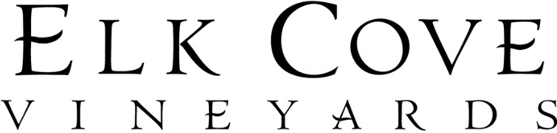

27751 NW Olson Road, Gaston, Oregon 97119 503.985.7760
elkcove.com
…………………………………………………………………………………………………………………………………………………….

FOUNDERS Joe and Pat Campbell
OWNERS Adam & Carrie Godlee-Campbell, Pat & Joe Campbell

YEAR ESTABLISED 1974
WINEMAKERS Adam Campbell and Heather Perkin
FIRST VINTAGE 1977
VINEYARD MANAGER Travis Watson

VINEYARD ACRES FARMED 370
VARIETIES PRODUCED Pinot gris, Pinot blanc, Riesling, Chardonnay, Pinot noir
SUSTAINABILITY CERTIFICATIONS Salmon Safe
CASE PRODUCTION 45,000
…………………………………………………………………………………………………………………………………………………….

Elk Cove Vineyards has been producing wines from Oregon's Northern Willamette Valley since 1974. While our focus is on Pinot noir, we also champion other grape varieties that thrive in our cool climate: Pinot gris, Pinot blanc, Riesling and Chardonnay. At our historic winery property in the Yamhill-Carlton AVA, we utilize hand- sorting, small-lot fermentation and extremely gentle handling to protect the inherent qualities of our fruit. Elk Cove owns and farms vineyards across six distinct, separate properties. Through specific site selection and meticulous vine management, we achieve concentration and depth of flavor in the vineyard. In addition to our Willamette Valley Pinot noir, we produce Single Vineyard Pinot noirs from each of our six estate properties, reflecting the terroir of both the Chehalem Mountains and the Yamhill-Carlton AVAs. These bottlings are typically from older vines, and -we hope- truly tell the story of each vineyard site: Mt. Richmond, La Bohѐme, Roosevelt, Goodrich, Clay Court and Five Mountain.

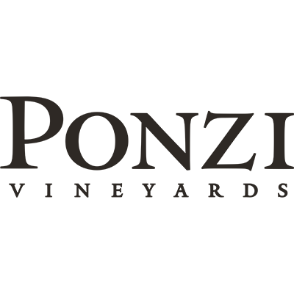

27751 NW Olson Road, Gaston, Oregon 97119 503.985.7760
elkcove.com
…………………………………………………………………………………………………………………………………………………….

OWNERS The Ponzi Family
WINEMAKER Luisa Ponzi
FIRST VINTAGE 1974
VINEYARD MANAGER Miguel Ortiz

VINEYARD ACRES FARMED 140
VARIETIES PRODUCED Chardonnay, Pinot noir, Pinot gris, Pinot blanc, Riesling, Dolcetto Arneis, sparkling wine
SUSTAINABILITY CERTIFICATIONS LIVE
CASE PRODUCTION 40,000
…………………………………………………………………………………………………………………………………………………….

When it comes to American Pinot noir, few possess the rich history and experience of Ponzi Vineyards, one of Oregon’s pioneering wineries. The winery was founded in 1970 by Dick and Nancy Ponzi, who realized the Willamette Valley met every need of noble, cool-climate grape varieties. Ponzi Vineyards was recognized early on as a premier producer of Pinot noir and instrumental in putting Oregon on the map as a world class wine region. This tradition of excellence is carried on with second-generation winemaker Luisa Ponzi and president Anna Maria Ponzi at the helm for the past 25 years. Moving ever forward, the winery continues to be a leader in Pinot noir and Chardonnay innovation and remains at the forefront of American wine, as one of Oregon’s legendary producers.

